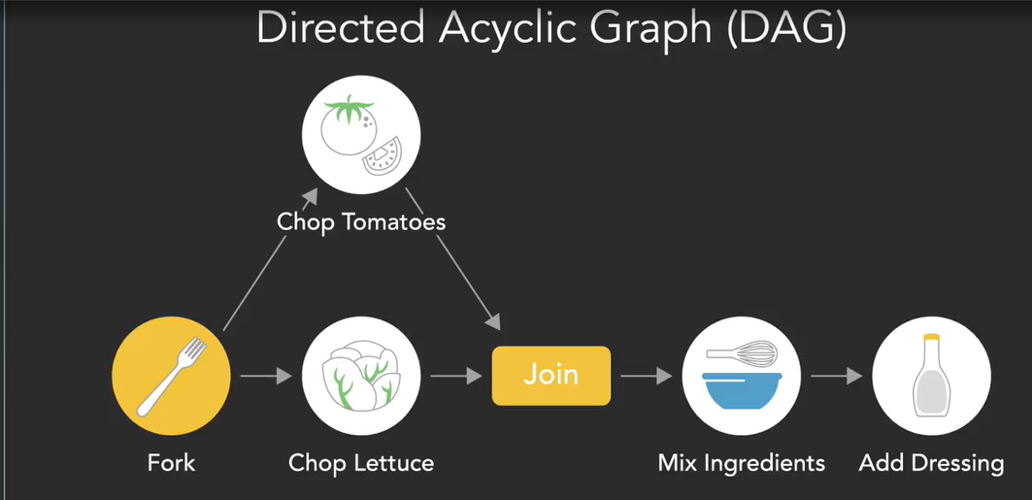


Thread pool
Thread Pool
Creates and maintains a collection of worker threads
Reuses existing threads to execute tasks

ExecutorService Interface
Defined in java.util.concurrent package
Higher-level interface for running tasks
Includes features to manage the executor and task lifecycle

